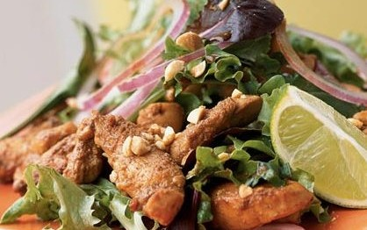

Stir-Fried Chicken Salad

SERVE FOR 4.

**Ingredients:**

* **1/4 cup fat-free, less-sodium chicken broth**
* **2 tablespoons rice wine vinegar**
* **1 tablespoon Thai fish sauce**
* **1 tablespoon low-sodium soy sauce**
* **1 tablespoon bottled chopped garlic**
* **2 teaspoons sugar**
* **1 pound skinless, boneless chicken breast tenders**
* **1 tablespoon peanut oil**
* **4 cups mixed salad greens**
* **1/4 cup chopped fresh basil**
* **1/2 cup thinly sliced red onion**
* **2 tablespoons finely chopped unsalted, dry-roasted peanuts**

**METHOD**

1. **Combine first 6 ingredients in a medium bowl. Add chicken to broth mixture, stirring to coat. Let stand 3 minutes.**
2. **Heat oil in a large nonstick skillet over medium-high heat. Drain chicken, reserving marinade. Add chicken to the pan; cook 4 minutes or until done, stirring frequently. Stir in the reserved marinade. Reduce heat; cook 1 minute or until slightly thickened. Remove pan from heat.**
3. **Combine greens and basil in a large bowl. Add chicken mixture, tossing to coat. Place 1 1/4 cups salad mixture on each of 4 plates. Top each serving with 2 tablespoons onion and 1 1/2 teaspoons peanuts. Serve immediately. Serve with lime wedges, if desired.**

**Note: The pan sauce in this dish doubles as a piquant vinaigrette for the salad. Serve with crunchy breadsticks, if you wish.**

[**source:**](http://www.myrecipes.com/recipe/stir-fried-chicken-salad-10000001185418/)